**WT ASSIGNMENT 4**

SHEFALI BISHT, BCA 1EB, 06229802021

Q1. Think of a creative idea/theme and design an attractive website on the basis of that theme consisting of 4-5 webpages minimum. Make use of HTML, Javascript, CSS and Bootstrap to make it more and more useful and appealing.

* I made a quiz website which includes webpages : Main or index page, About us, Support us, Quiz and a Sign up form using html, css, bootstrap and Javascript.

**INDEX PAGE**

**CODE:**

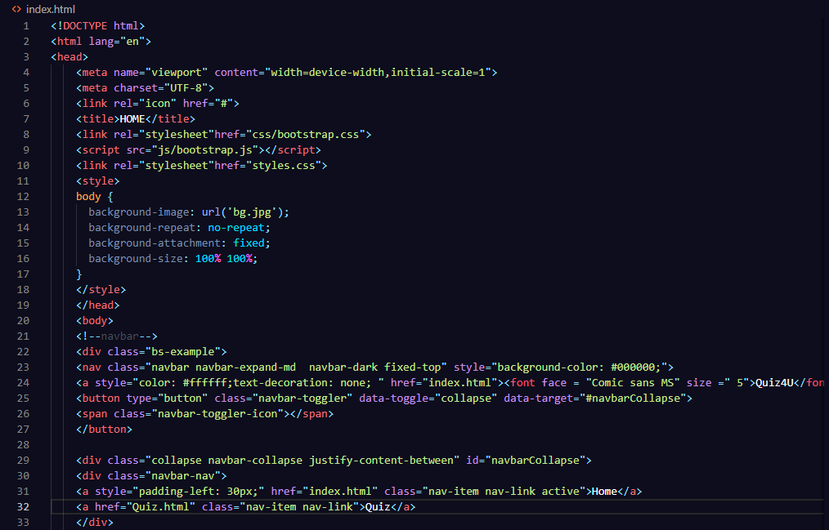

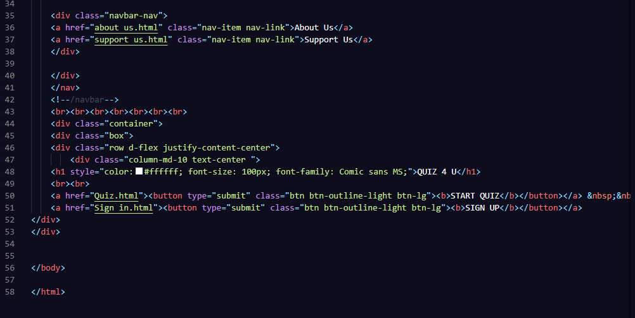

**OUTPUT:** 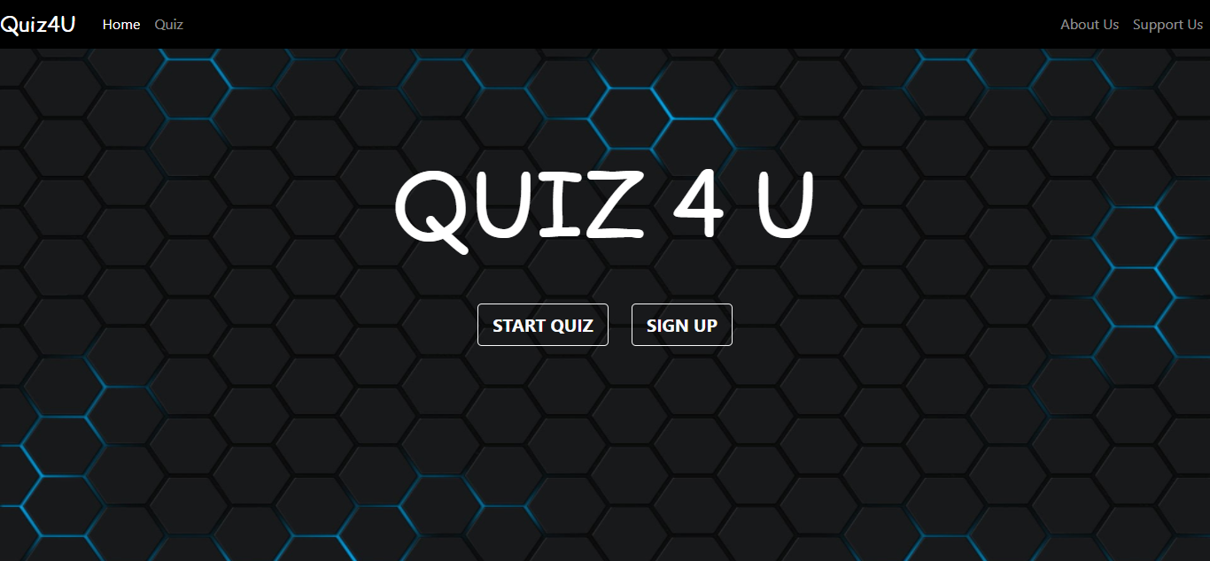

**ABOUT US**

**CODE:**

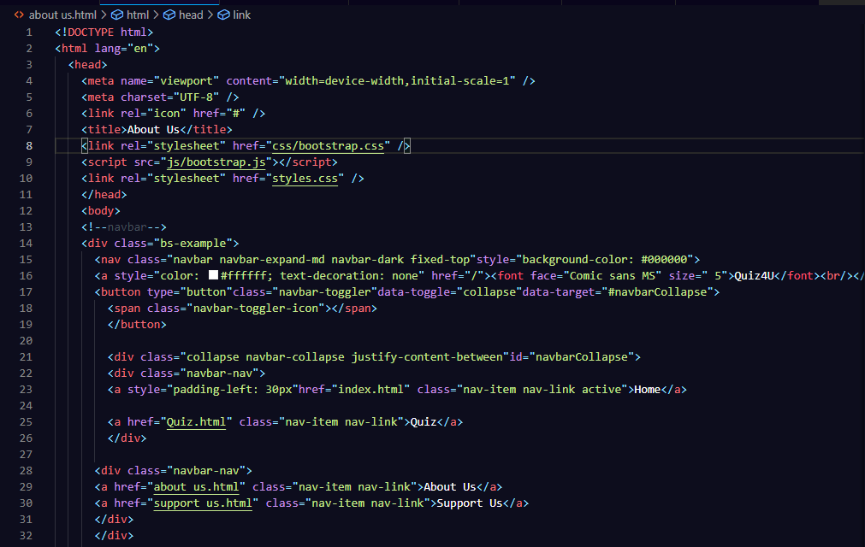

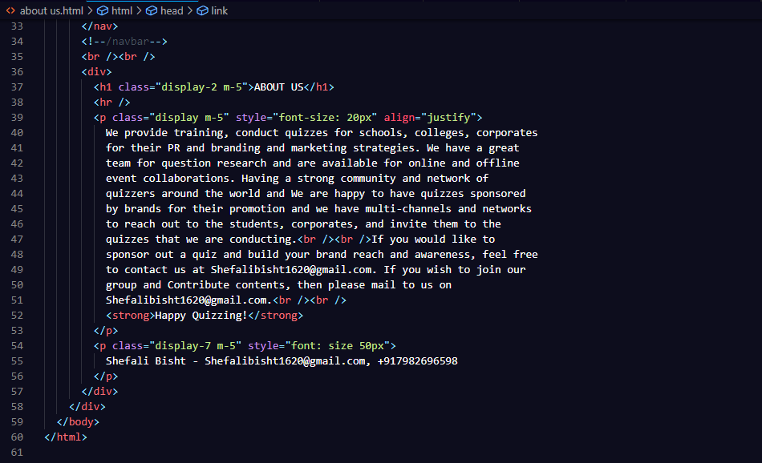

**OUTPUT:**

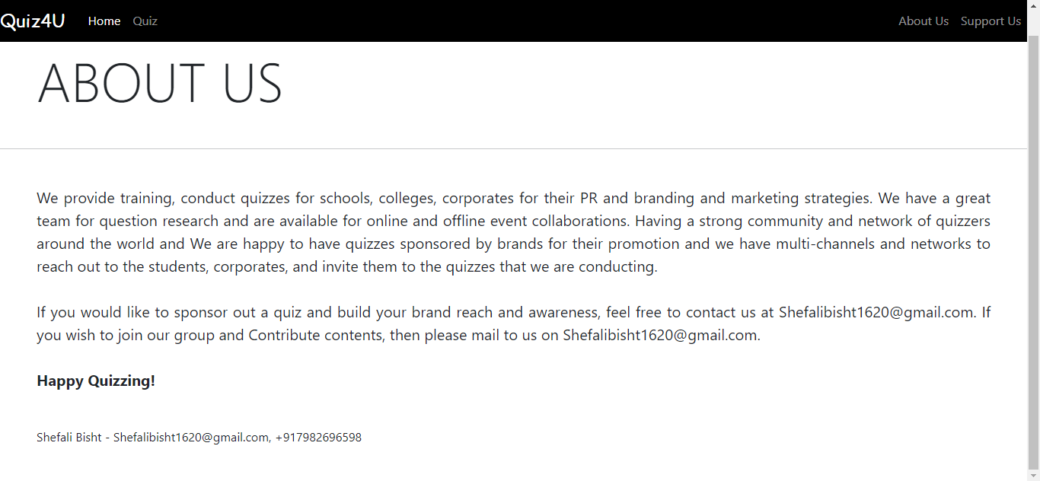

**SUPPORT US**

**CODE:**

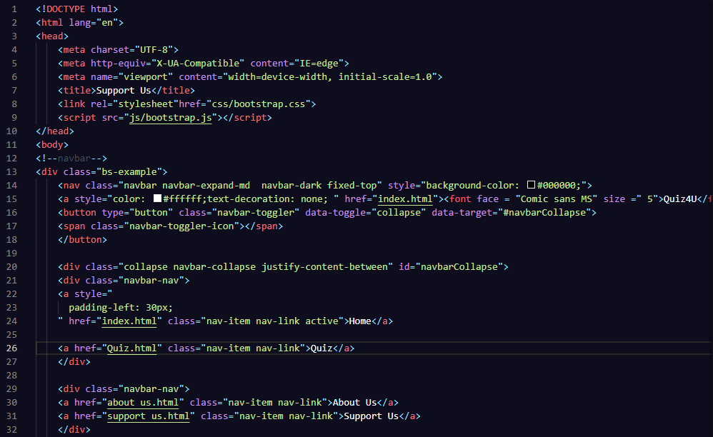

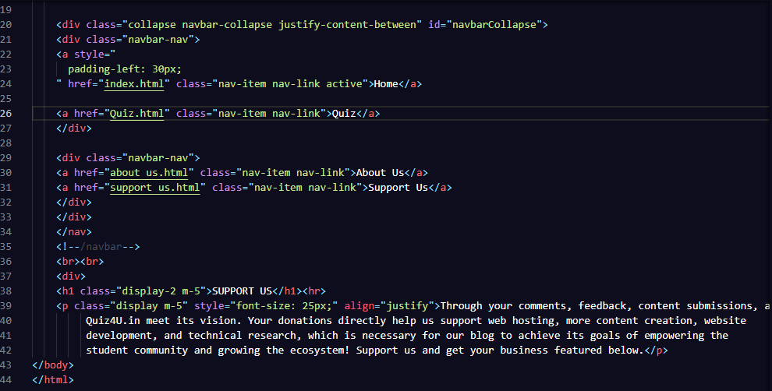

**OUTPUT:**

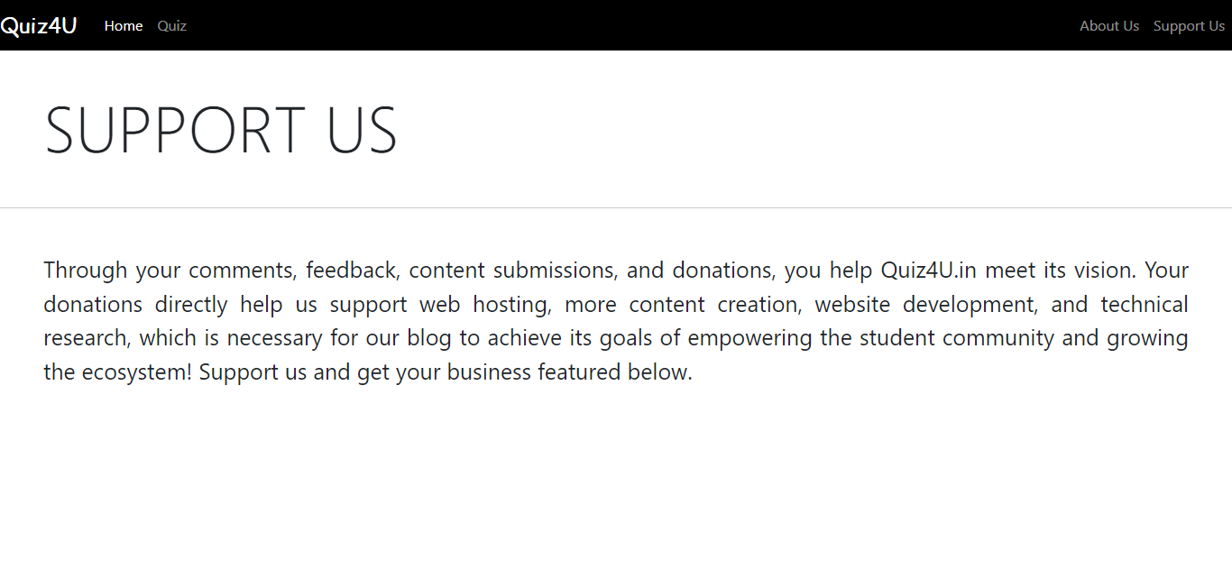

**START QUIZ**

**CODE:**

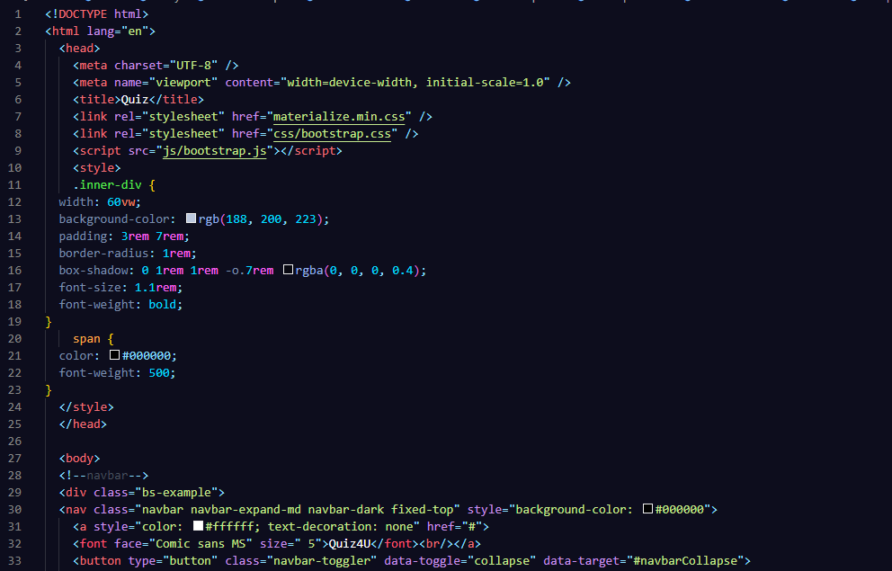

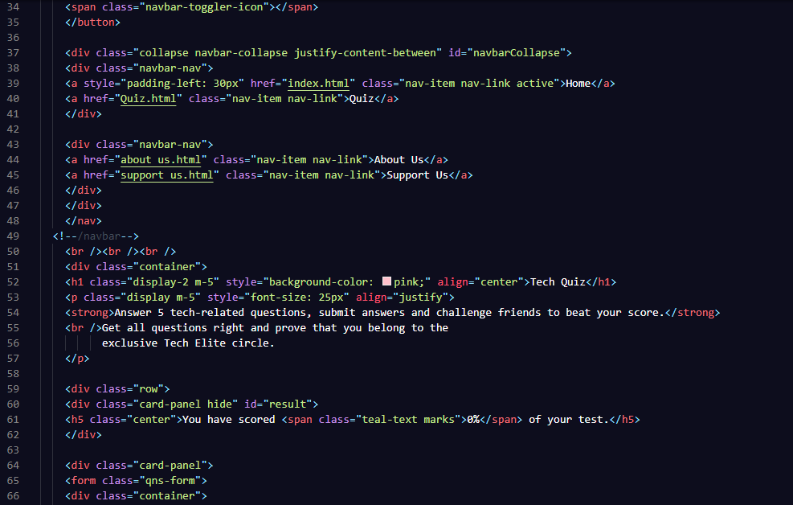

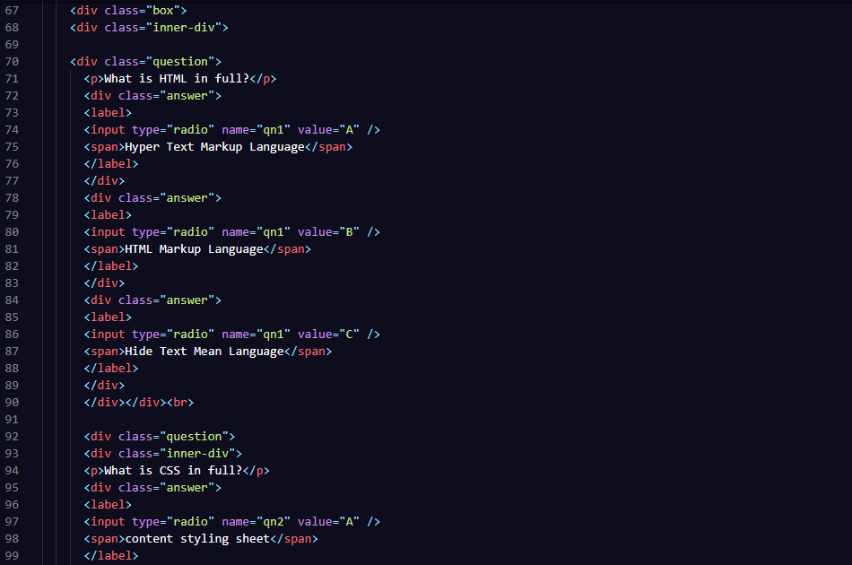

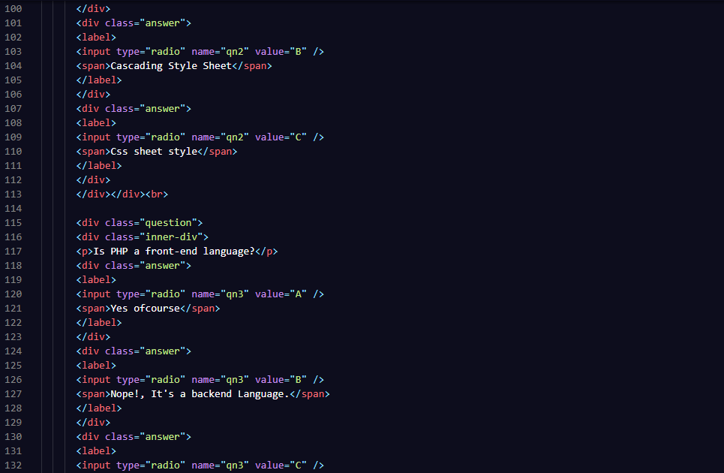

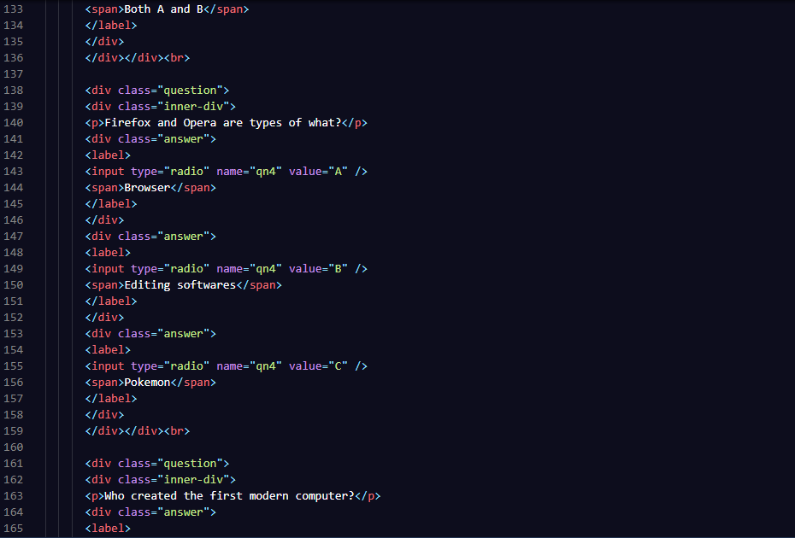

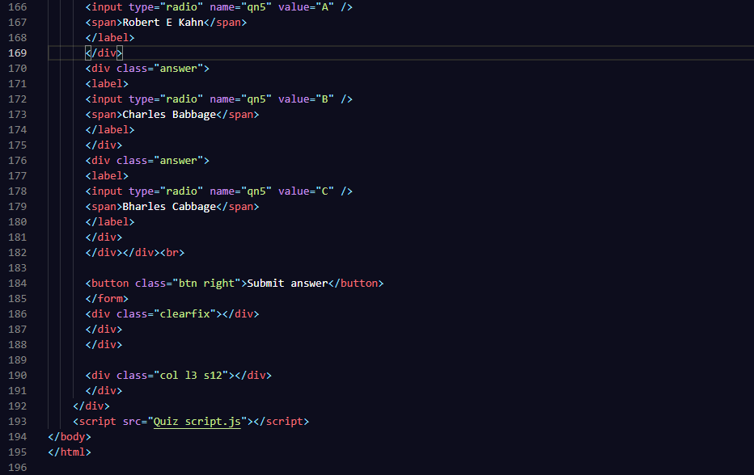

**JAVASCRIPT CODE:**

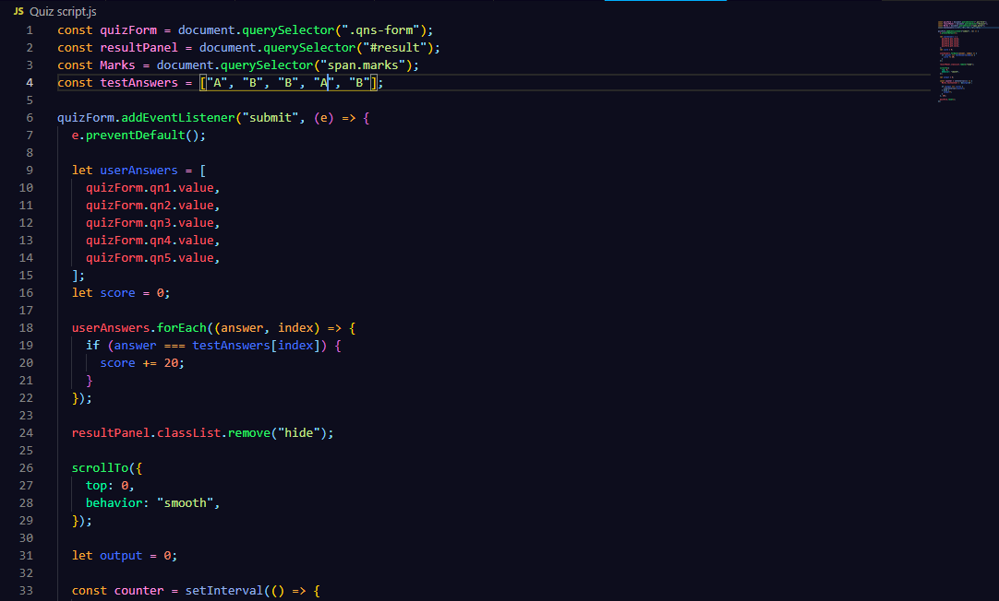

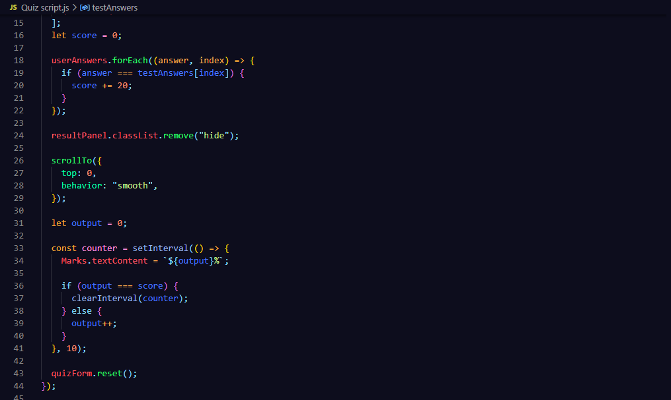

**OUTPUT:**

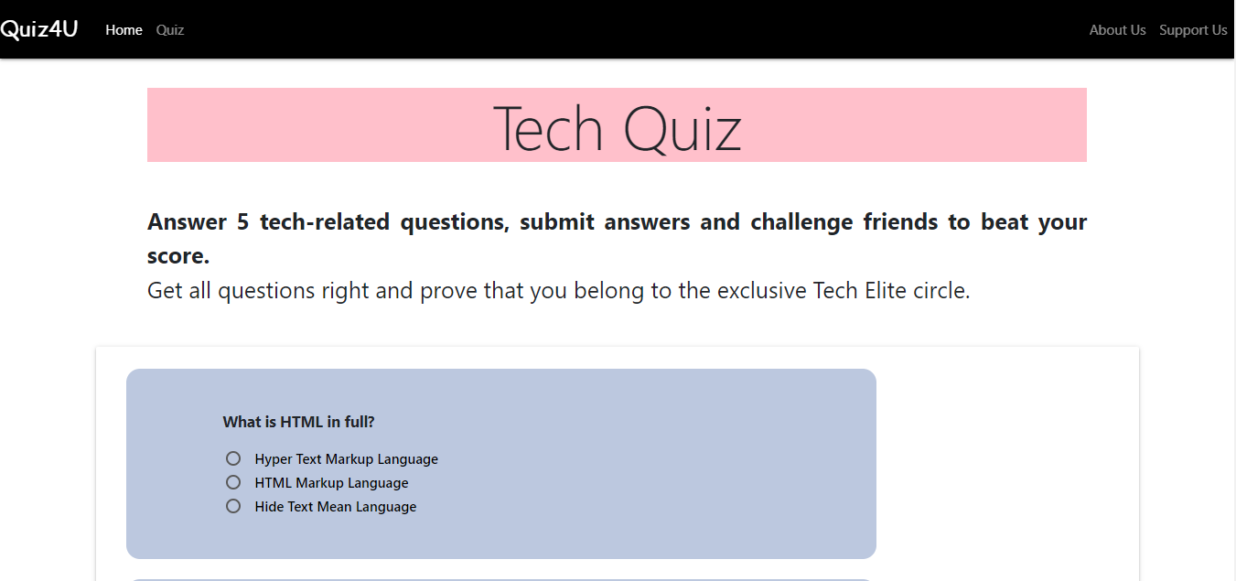

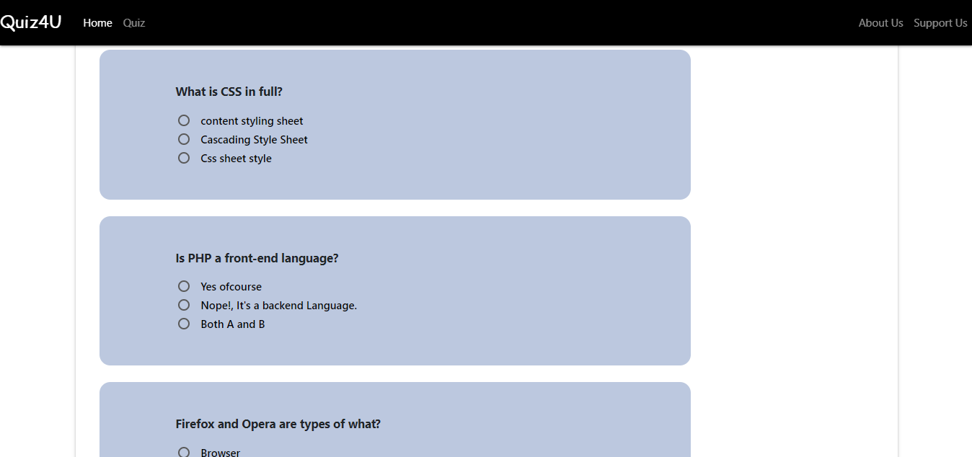

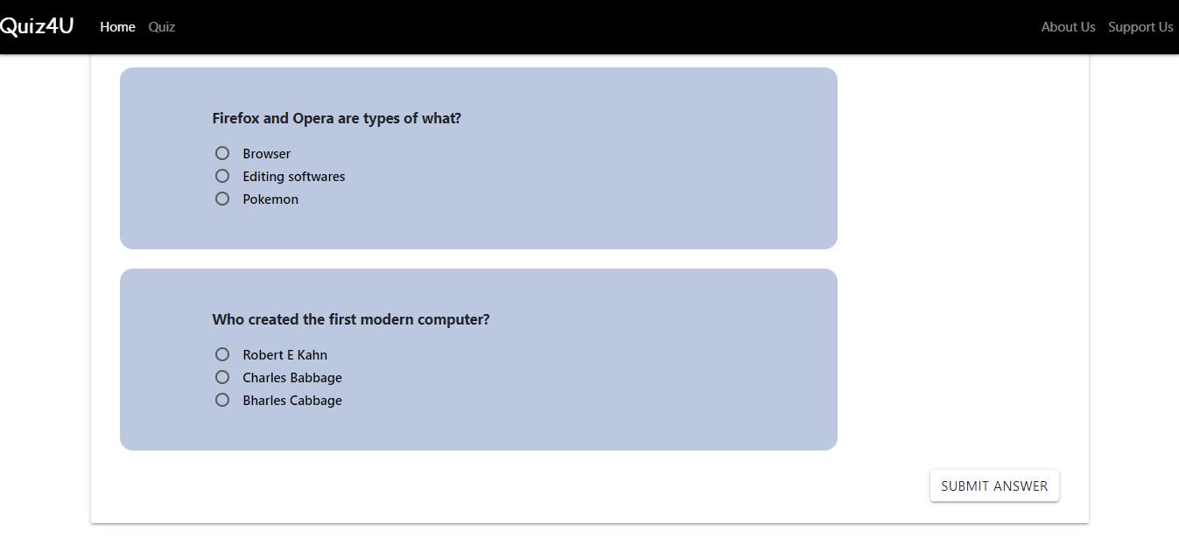

**QUIZ SHOWING RESULT:**

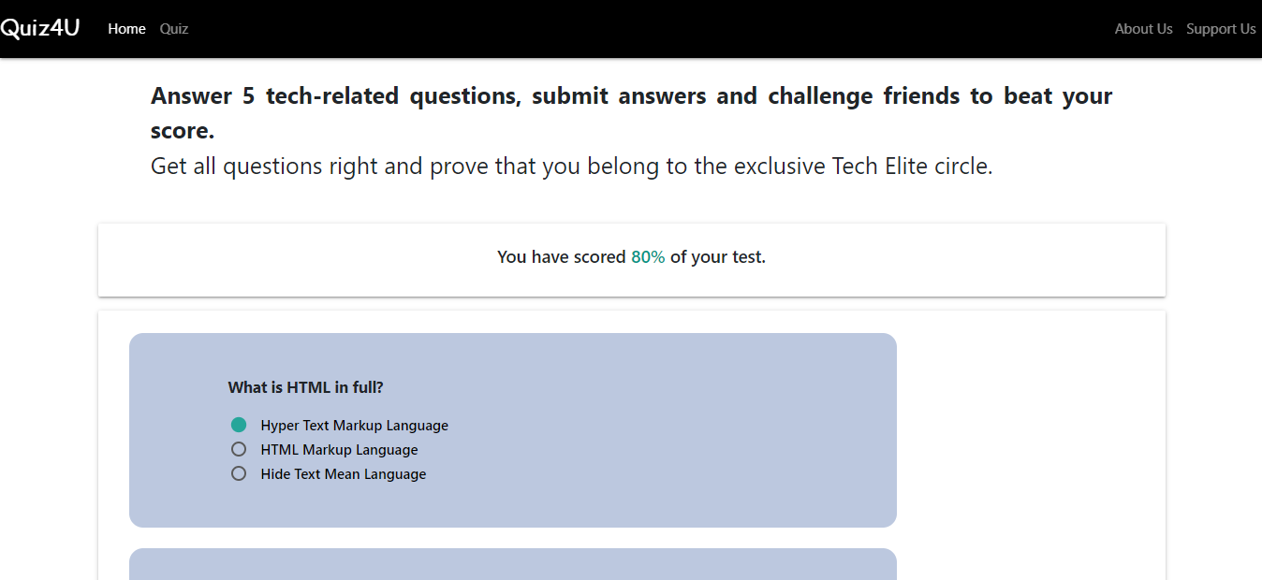

**SIGN UP**

**CODE:**

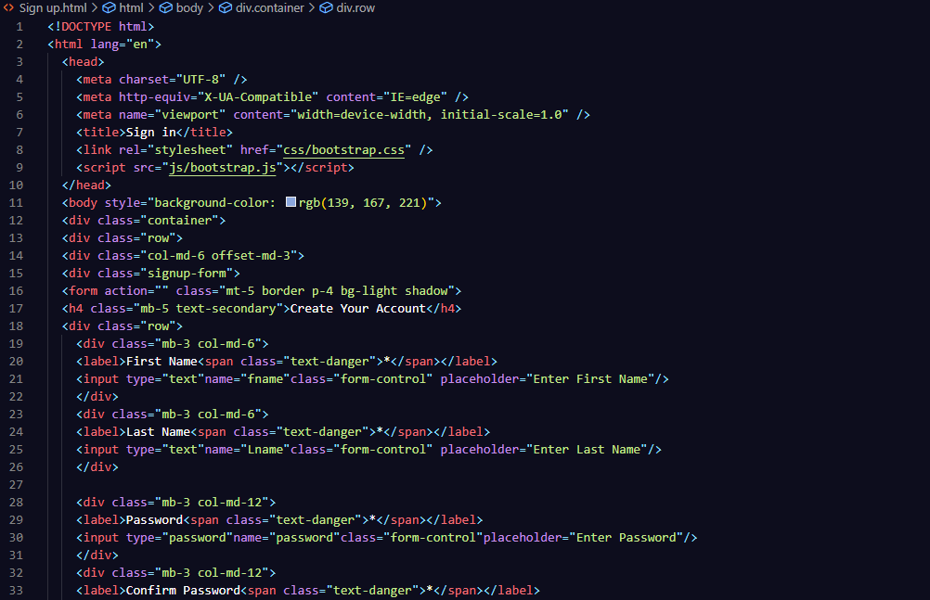

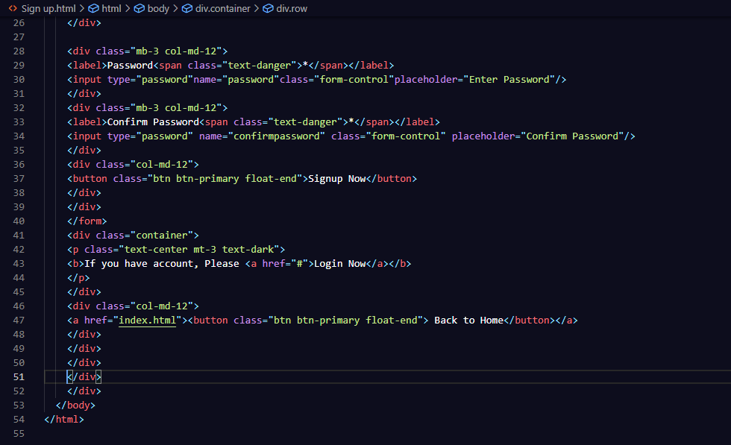

**OUTPUT:**

